***<Data Information>***

* The dataset contains 136 beverage items and 12 columns.
* All columns are of type object and may require additional data preprocessing.
* There are no missing values ​​in the dataset and all columns have complete values.
* descriptive statistics.
* The Menu column has 136 unique values, and each drink is unique.
* The Category column has eight unique categories, with the most drinks falling into the Slush category.
* The Flavor Tags column contains 95 unique tags, with Creamy and Normal appearing most frequently.
* Most drinks have a Customizable Sweetness option marked Yes.

***<EDA>***

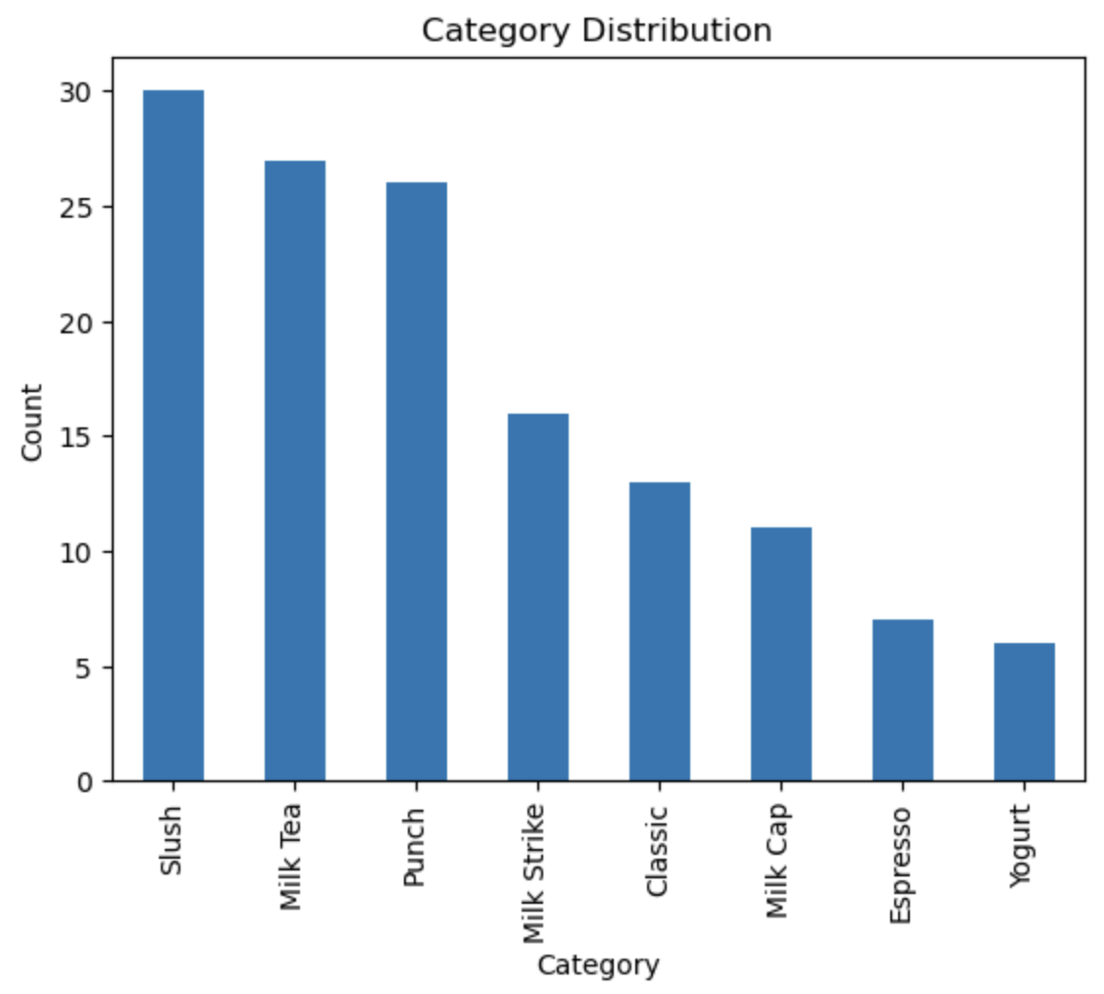

* Slush is the most popular beverage category, with about 30 items.
* Milk Tea and Punch were the second most offered categories, with about 25 each.
* Yogurt and Espresso are the categories with the fewest items.

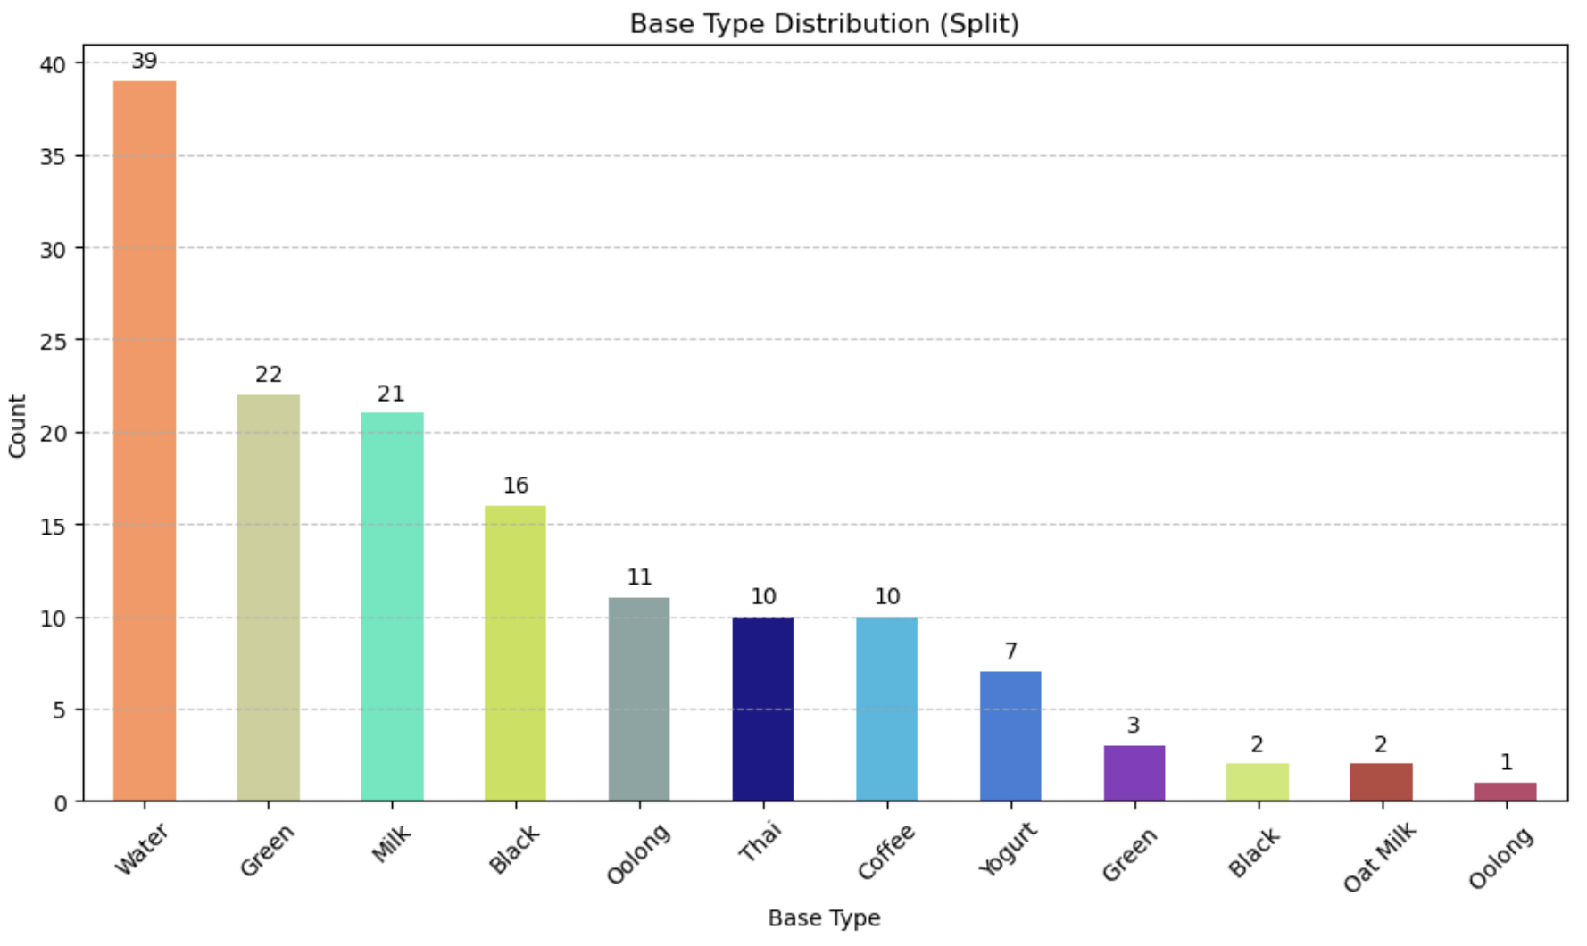

* There are 39 drinks using the 'Water' base, the most, showing that it occupies an important role in the menu.
* 'Green', 'Milk' and 'Black' followed suit and are used in about 20 more drinks.
* Bases such as 'Yogurt', 'Thai' and 'Coffee' are used relatively less frequently, while alternative bases such as 'Oat Milk' are used very less frequently.

**<Flavor Tag & Overall Beverage Tag Word Cloud + Flavor Tag Frequency>**

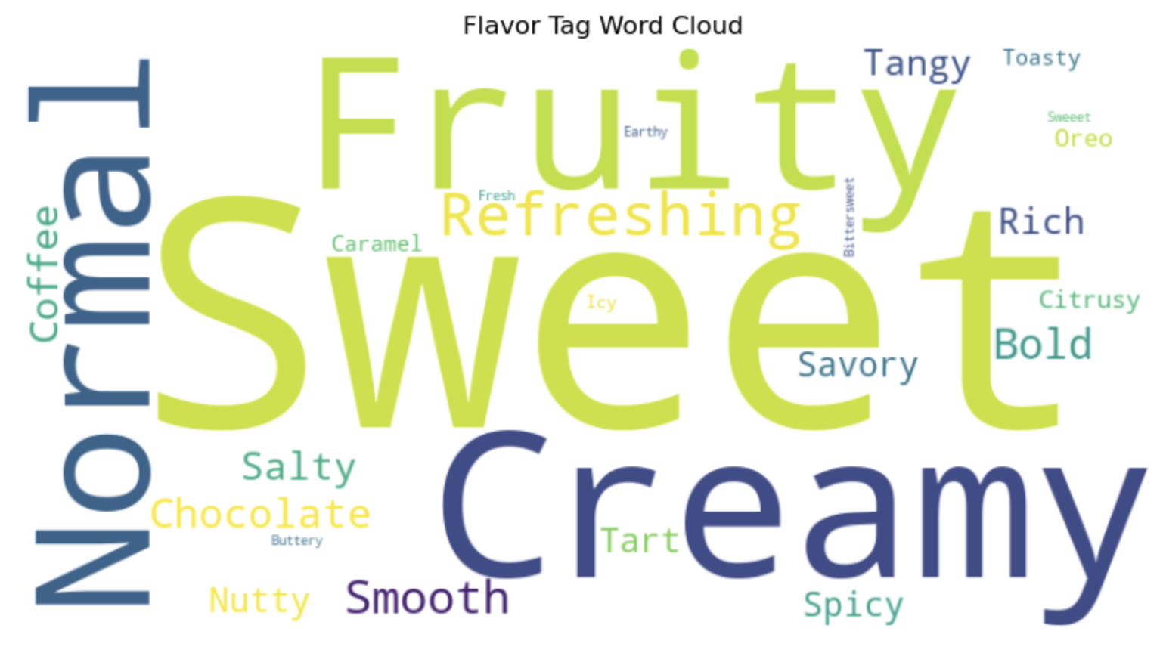

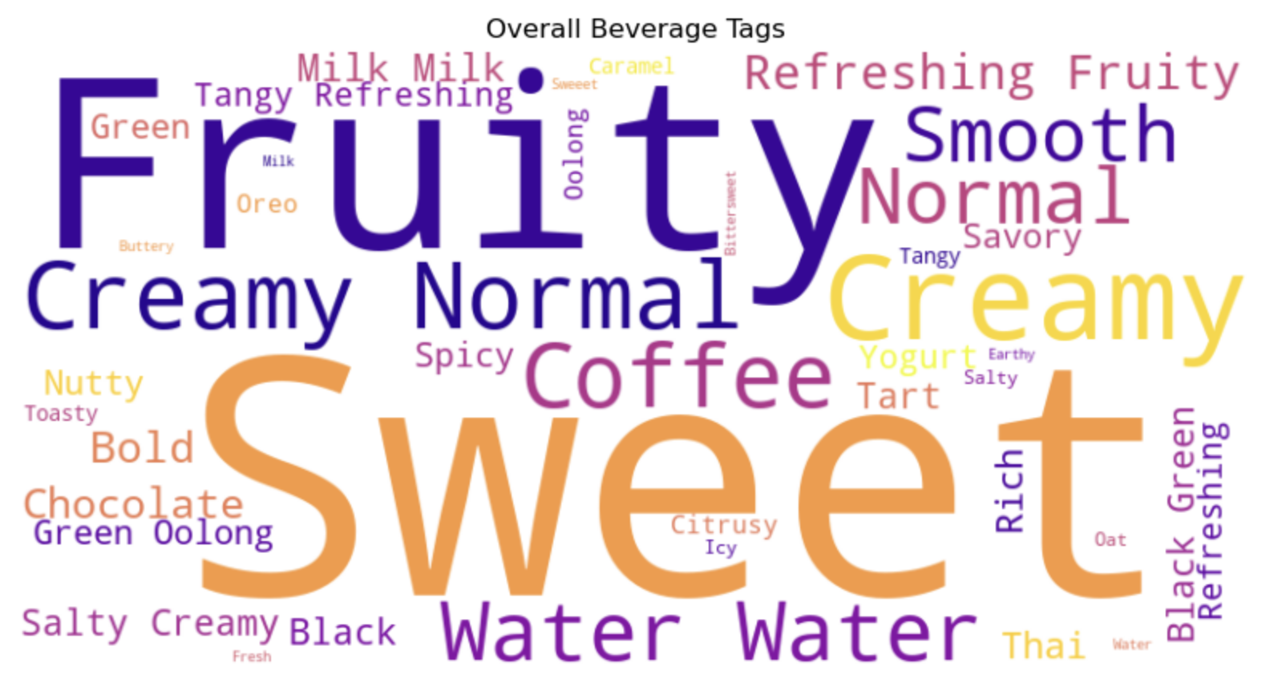

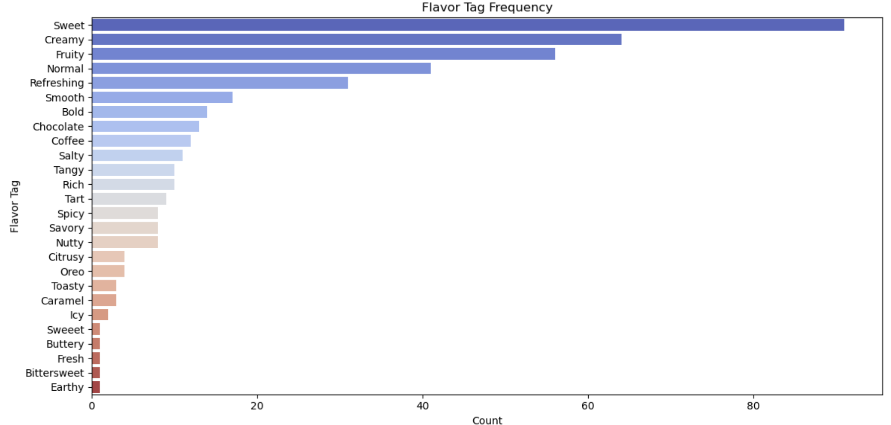

* Covering tags across beverages, the tags "Sweet," "Fruity," "Normal," and "Creamy" still stand out, while specific flavors like "Coffee" also appear to show overall taste preference tags. A comprehensive analysis shows that flavors such as “Sweet” and ,”Creamy”,“Fruity” are the most common.

**<Proportion of Caffeine, Vegan, Gluten-Free, and Oat Milk Substitution in Beverages>**

1. Oat Milk Substitution: Only 11.8% of all beverages are replaceable with Oat Milk, and the majority (88.2%) are not replaceable.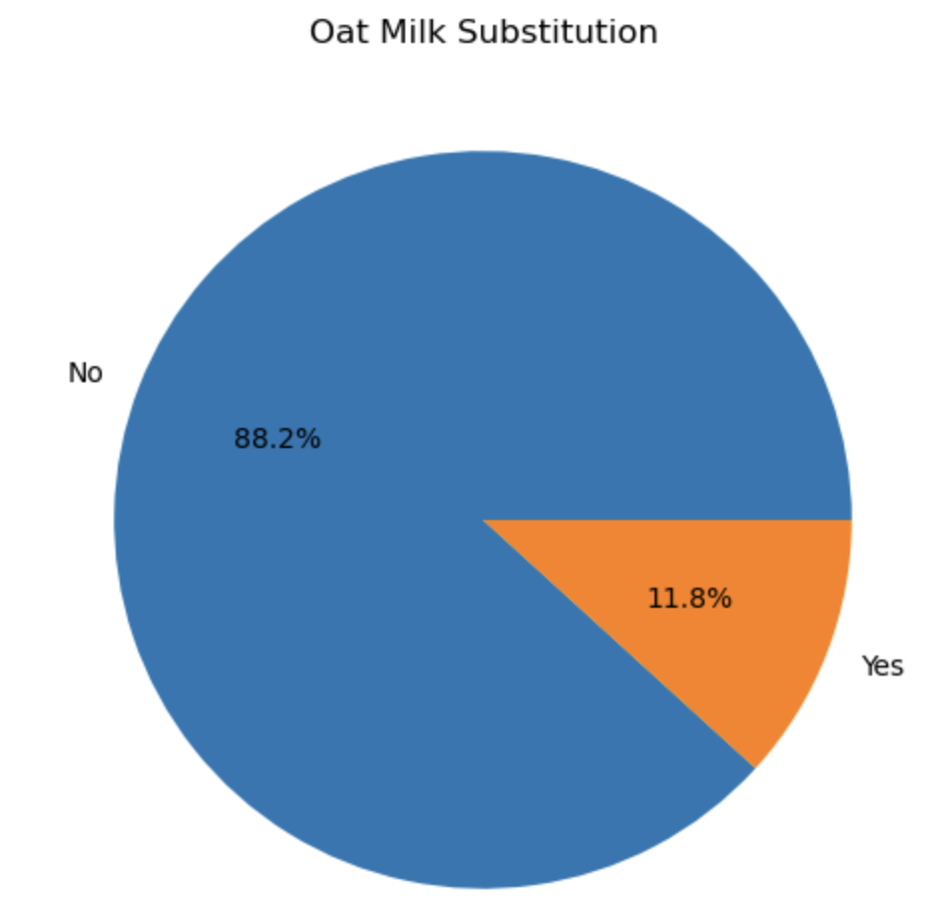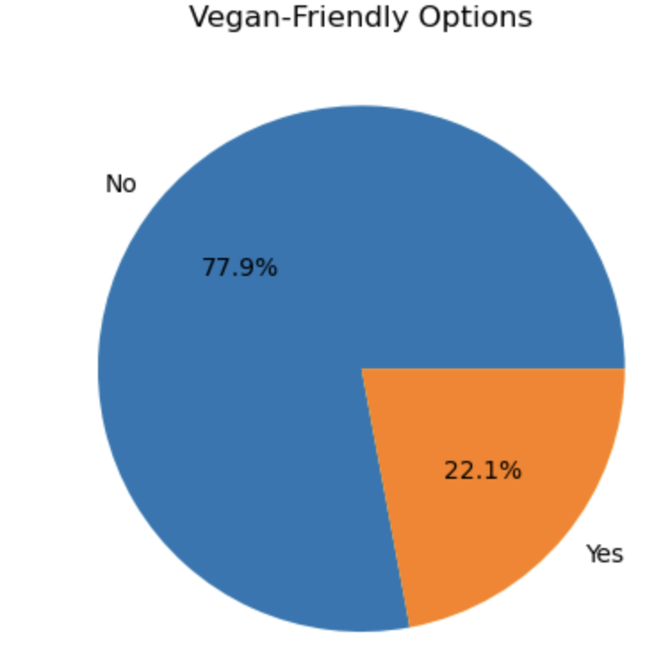

* Conclusion: Oat milk alternative options are limited, which may be inconvenient for non-product consumers.

2. Vegan-Friendly Options: Beverages with Vegan-Friendly options are 22.1%, and most (77.9%) are only suitable for non-vegetarians.

* Conclusion: We need to expand our Vegan-friendly beverage options.

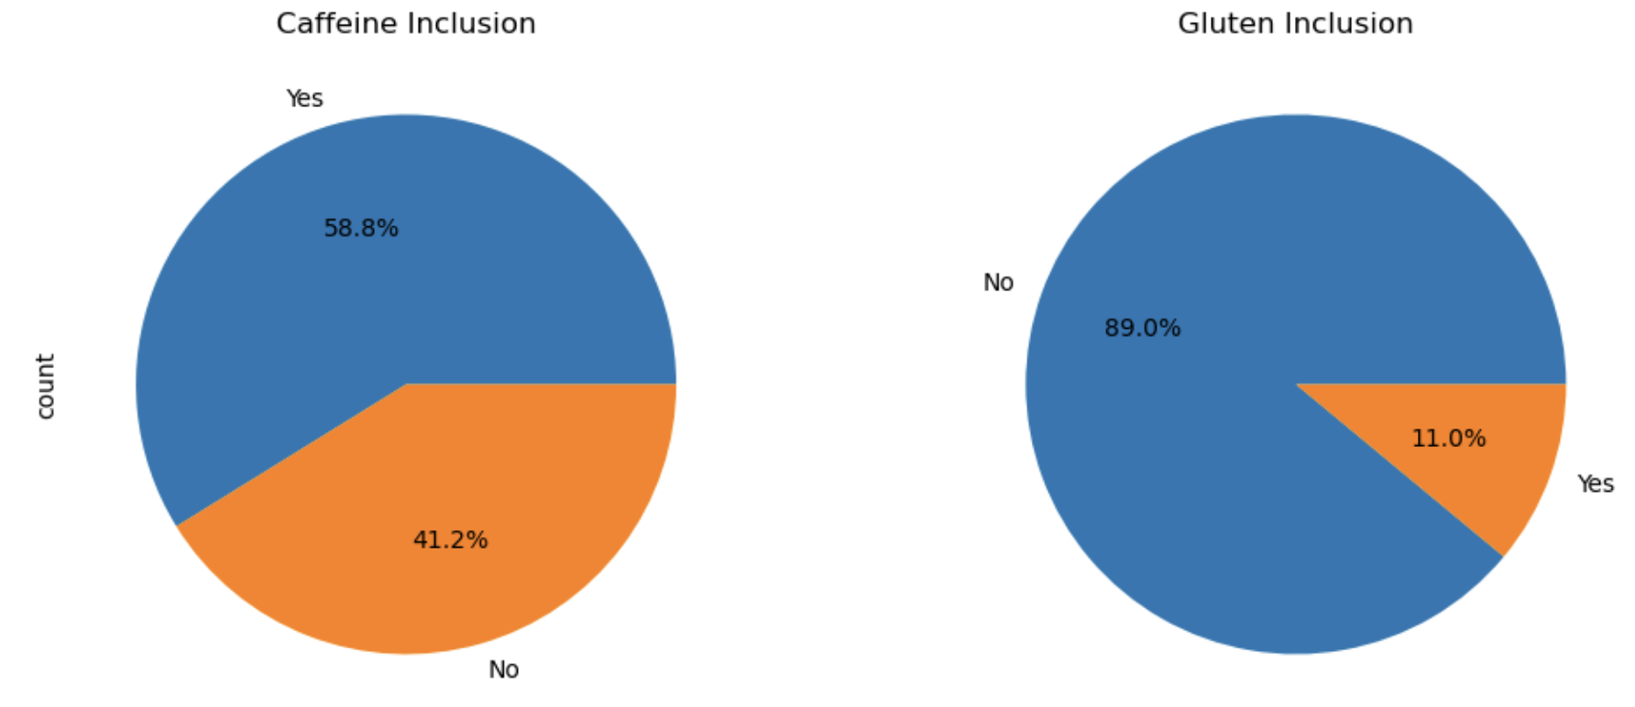

3. Caffeine Inclusion: 58.8% of drinks contain caffeine, while 41.2% contain no caffeine.

* Conclusion: Caffeine and non-caffeine drinks are properly balanced.

4. Gluten Inclusion: 11% of drinks contain gluten, and 89% contain no gluten.

* Conclusion: Most drinks offer gluten-free options, which are suitable for a gluten-restricted diet.

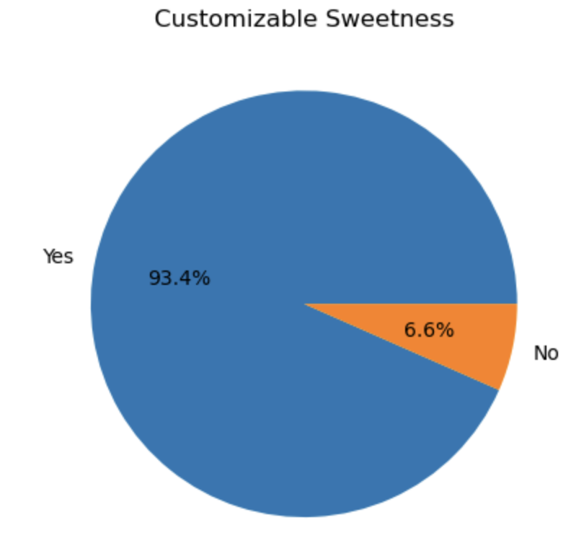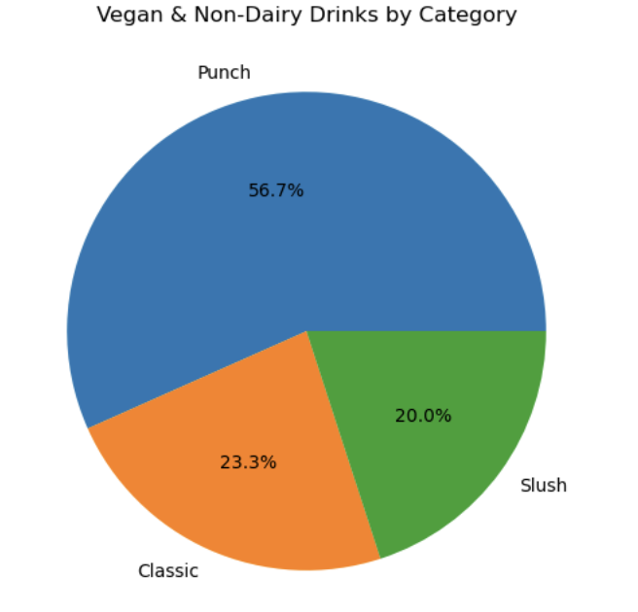

5. Customizable Sweetness: 93.4% of all beverages are customizable Sweetness, and 6.6% are not. It shows that most beverages offer the option to reflect customers' sugar preferences.

* Conclusion: This result is positive in that most beverages provide flexibility to meet various needs of customers, and support a personalized beverage experience.

6. Vegan & Non-Dairy Drinks by Category: Vegan and dairy alternative drinks are most frequently served in Punch (56.7%), followed by Classic (23.3%) and Slush (20.0%).

* Conclusion: Vegan-friendly and dairy alternative options are focused on specific categories, with room for expansion to other categories. Punch is likely to be a major choice for Vegan customers.

Summary of the previous graphs:

* Vegan-friendly and Oatmilk substitution options are relatively limited.
* The Caffeine and Gluten-free options show a sufficient distribution to meet different consumer needs.
* Vegan and Non-Dairy options are concentrated in certain categories, so it would be good to expand to other categories.

The most popular combination is Water | Sweet, Refreshing, and Fruit, which is the most selected base and flaver tag combination.

Milk | Creamy, Sweet, Chocolate and Green | Refreshing, Fruit combination followed by high frequency.

Keywords such as Sweet, Creamy, Refreshing, and Fruit Flavor are repeatedly featured in the top combination, showing the characteristics of flavors that customers prefer.

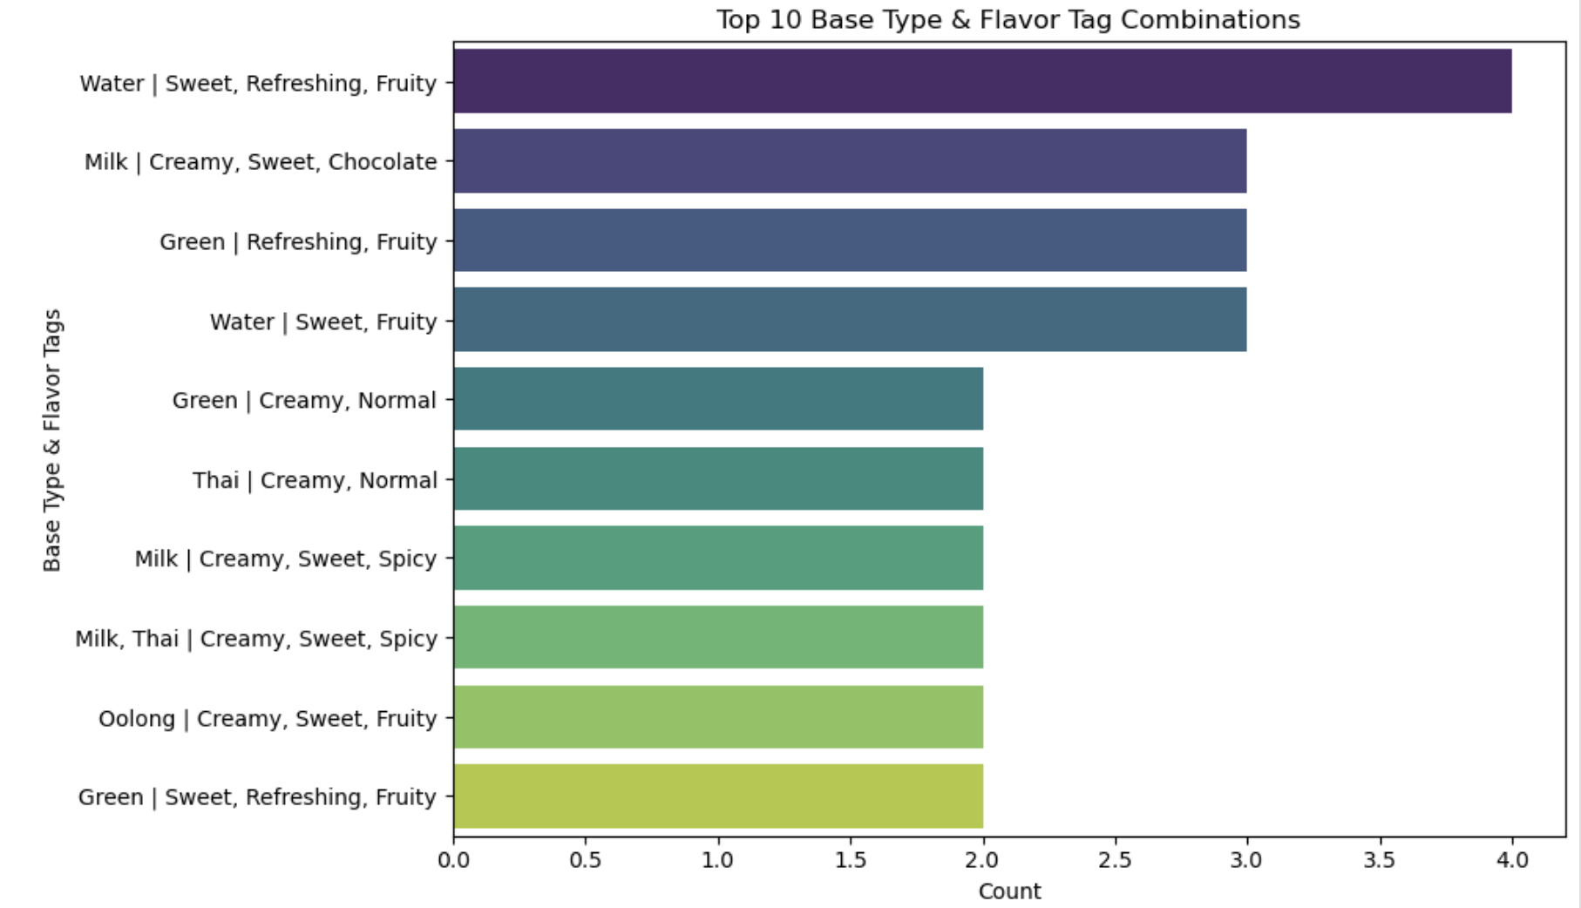

* The most popular combination is Water | Sweet, Refreshing, and Fruit, which is the most selected base and flavor tag combination.
* Milk | Creamy, Sweet, Chocolate and Green | Refreshing, Fruit combination followed by high frequency.
* Keywords such as Sweet, Creamy, Refreshing, and Fruit Flavor are repeatedly featured in the top combination, showing the characteristics of flavors that customers prefer.

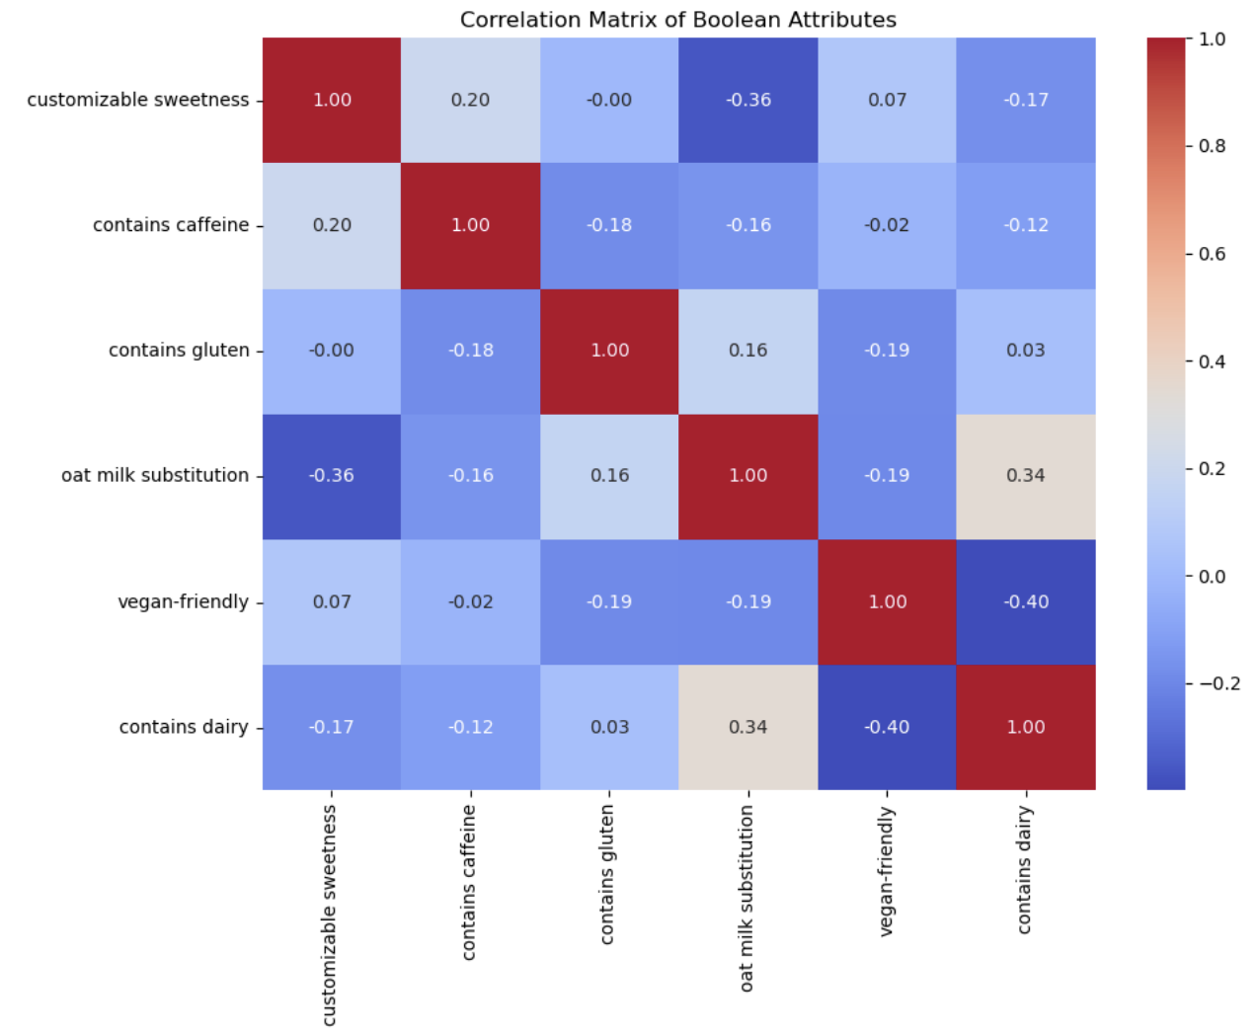

1. Strong negative correlation (-0.40):

- "Vegan-friendly" and "Contains dairy" have a negative correlation

- Dairy-Included Beverages Most Likely Not Vegan Options

2. Positive correlation (0.34):

- The correlation between "Oat milk substitution" and "Contains dairy" is positive

- Dairy beverages tend to have more frequent oat milk alternatives

3. Weak correlation:

- The biggest feature is that there is weak or little correlation between most properties, usually independent properties

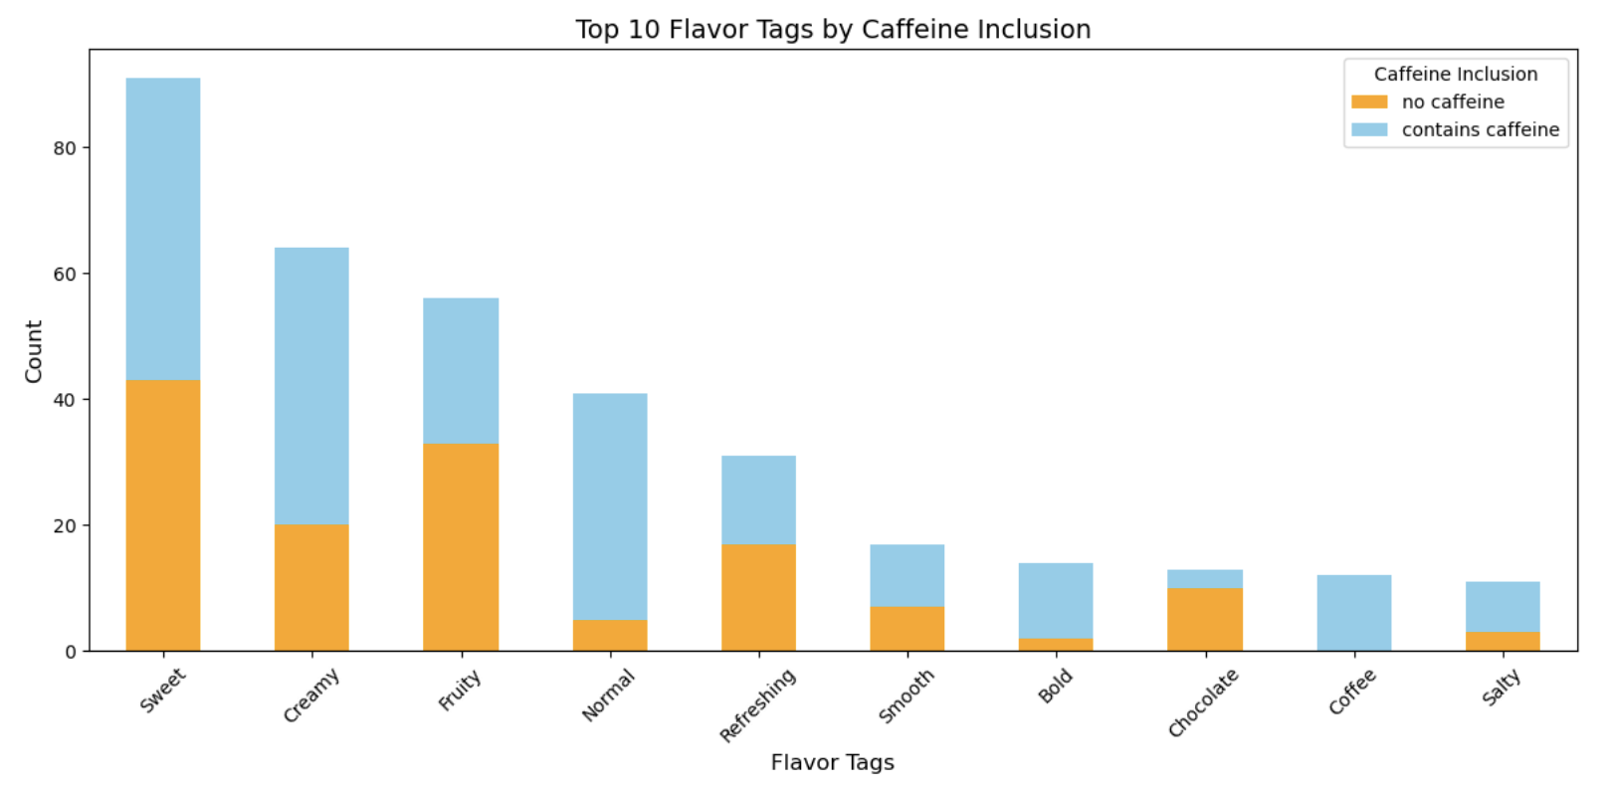

* Tags such as Sweet, Creamy, and Fruity appear the most, of which Sweet and Creamy have a high frequency with or without caffeine.
* Caffeine-containing drinks also make up a significant number in Fruity and Refreshing tags, and this combination appears to be popular.
* The Bold, Chocolate, and Coffee tags mainly belong to caffeinated beverages, reflecting the expected flavor characteristics.
* Sweet and Creamy appear as the main tags even in caffeine-free drinks, but more diverse combinations of flavors are seen in relatively caffeine-containing drinks.

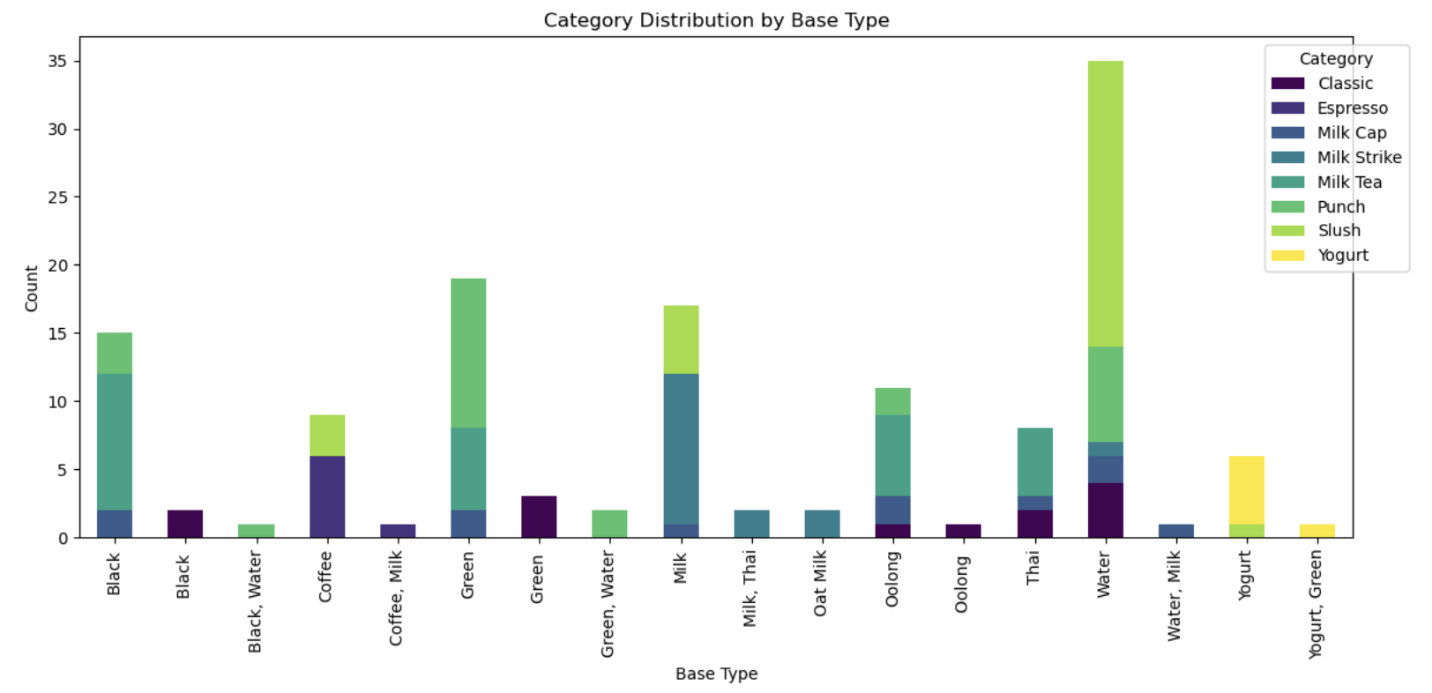

* Water and Milk-based drinks dominate most categories, with Punch and Milk Tea appearing as popular combinations.
* Green and Black Tea-based beverages stand out in combination with Milk Tea and Slush, with varying category distributions.
* Yogurt-based drinks are almost limited to Slush, allowing further combination possibilities to be explored.

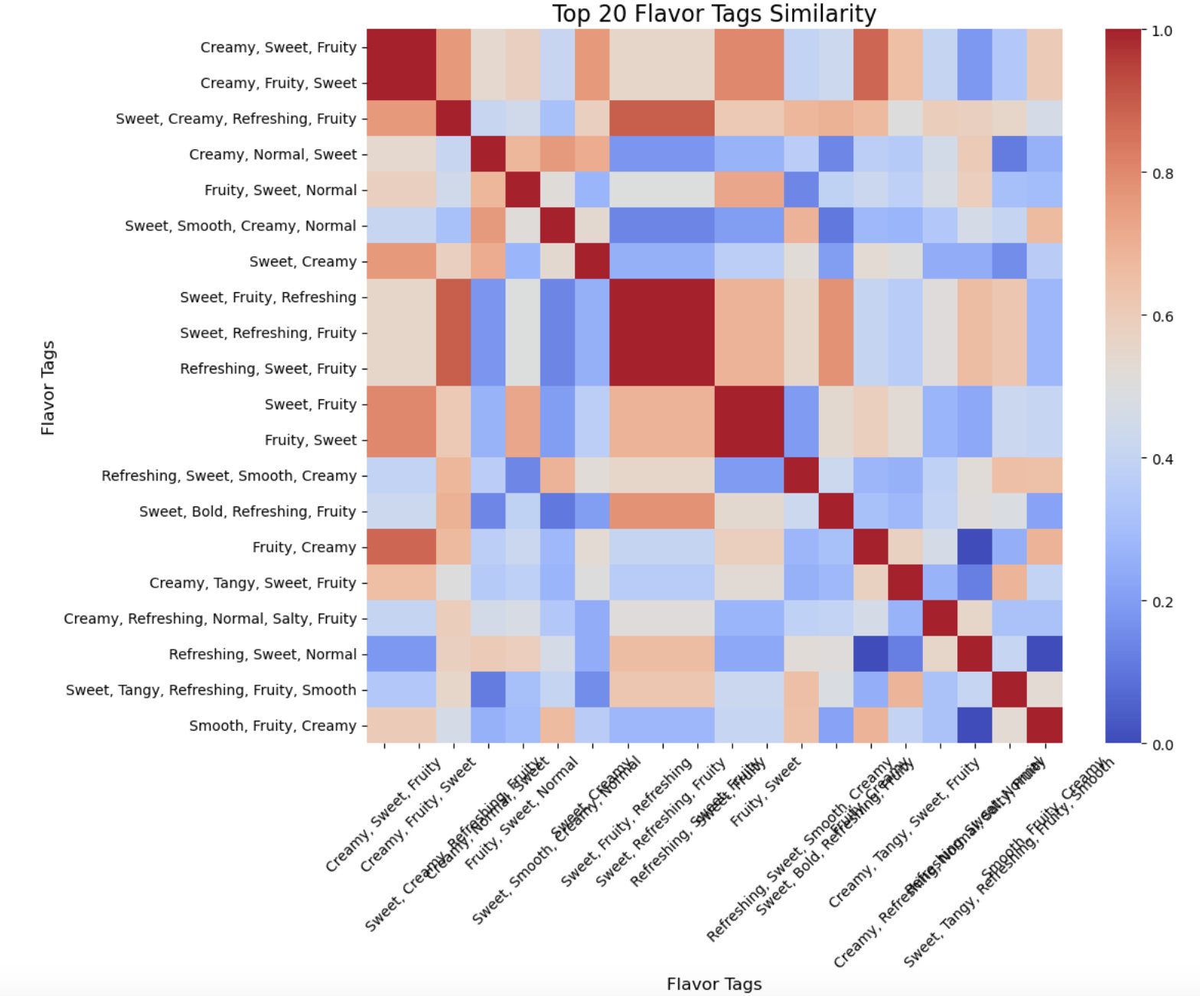

1. High-similar tag groups:

* "Creamy, Sweet, Fruity" and "Creamy, Fruity, Sweet" have almost perfect similarities, with very similar properties, with only different tag sequences.
* "Sweet, Fruit, Refreshing" and "Sweet, Refreshing, Fruit" also show high similarity and can be classified into the same attribute group.

2. Low-similarity tags:

* "Creamy, Normal, Sweet" and "Sweet, Tanguy, Refreshing, Fruity, Smooth" have almost no parallel, and exhibit completely different characteristics.

3. Patterns on tags:

* Tags with "Sweet" and "Creamy" are generally more similar than other tags.
* Combinations with unusual tags, such as "Tangy" or "Salty," often have low similarities.

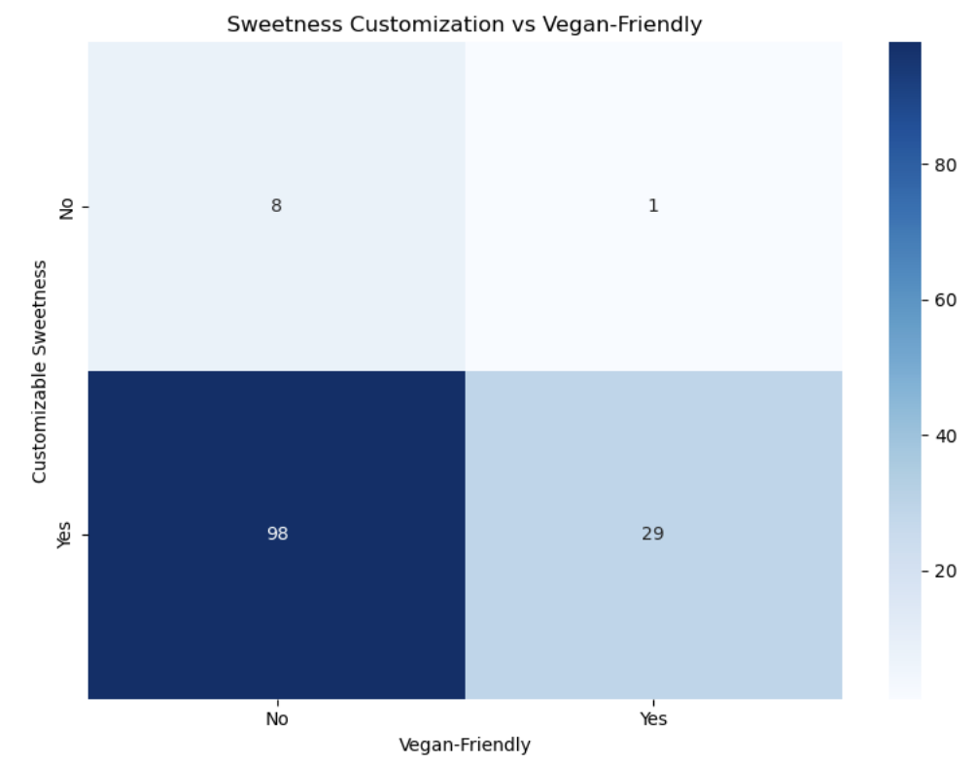

1-1. Sweetness Customization Possible:

* Beverages with Sweetness Customization are supported by most beverages, whether or not Vegan-Friendly.
* 29 of the Vegan-Friendly drinks support sweetness adjustment, and 98 of the non-Vegan-Friendly drinks are supported.

1-2. Vegan-Friendly Number of Optional Drinks:

* There are 98 drinks that do not offer Vegan-Friendly options, and there are 30 Vegan-Friendly optional drinks in total.

1-3. Beverages that do not support Sweetness Customization:

* Very few beverages do not support Sweetness Customization, whether or not Vegan-Friendly (9 in total).

2. Important points:

2-1. Most beverages can be sweetened:

* Whether Vegan-Friendly or not, most beverages support sweetening, which is likely to provide customized service.

2-2. Possible expansion of Vegan-Friendly options:

* Vegan-Friendly drinks often offer Sweetness Customization, which can be used as an additional marketing point to increase customer satisfaction.